Spatial development strategy of Slovenia 2050
Evaluation of its contribution to territorial cohesion
Mojca Golobič, University of Ljubljana, Biotechnical Faculty and Slovenian evaluation society, Bojan Radej, Slovenian evaluation society

5th Regional Conference of evaluators in Western Balkan Ljubljana, 29. – 30.9.2023
mojca.golobic@bf.uni-lj.si, bojan.radej@siol.net
Evaluation and territorial development: Why the national spatial policy (doesn't) get implemented?
1st Regional Conference of evaluators in Western Balkan Sarajevo, 28.-29.10.2015

Mojca Golobič, Naja Marot
University of Ljubljana, Biotechnical Faculty, Department for landscape architecture mojca.golobic@bf.uni-lj.si, naja.marot@bf.uni-lj.si

Conclusions
- SPRS already contains horizontal, integrated topics;
- Recognition and implementation of the document is not sufficient;
- The linkage of the SPRS with the development documents is missing;
- The horizontal (the competence of the Ministry for the sectoral coordination) and vertical integration (capacity of the local comunities, regional administration) needs to be improved.
…as we see the activities of the Ministry, its mostly managing the server where the materials are stored…
… We only use it (the Strategy) when it suits us, and we choose ony the paragraphs which confirm our standpoints. Else… as if it wasn‘t there.
…Sometimes it (the Strategy) does not support our aspirations – then we write down that the certain paragraph is not being taken into account.
… It (the Strategy) is also… harmless, to say it bluntly.

„The way forward“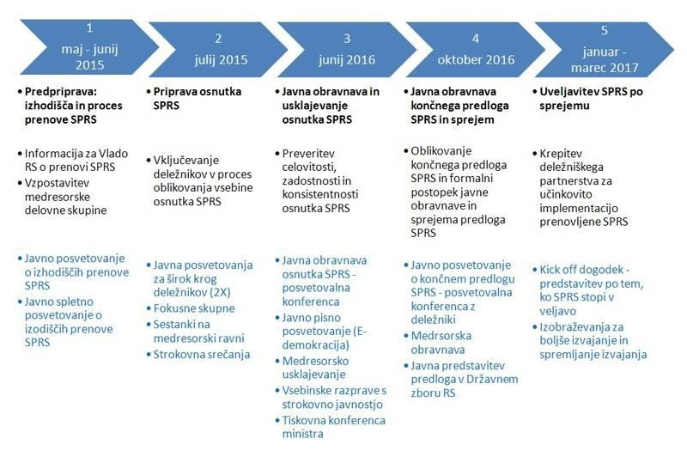

Aim of the evaluation
Aim: to assess the integration and the cohesion potential of the effects of the Strategy
Environmental
/
spatial
Social
Economic
Territorial
identity
Territorial
cohesion
Territorial
efficiency
Territorial
quality

Methods
Cross-sectional method based on a matrix evaluation
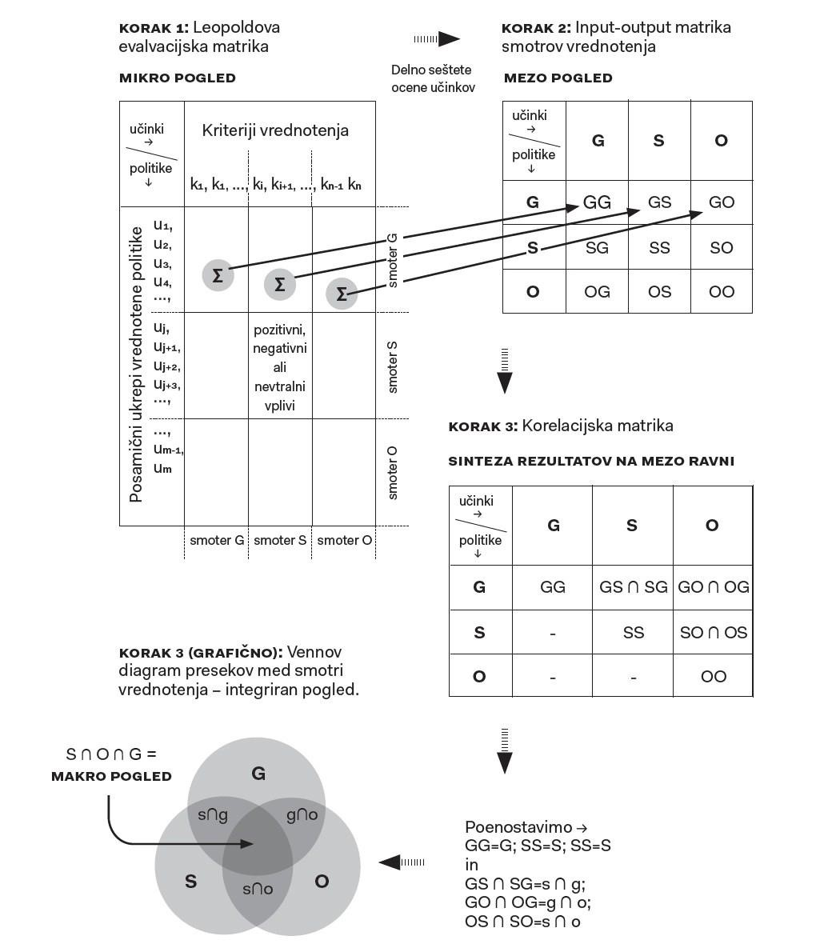
Effects of the Strategy were assessed by policy makers (with the support of the evaluation team) in focus group.
The obtained impact assessments were compared with baseline estimates of the indicators of the state and trends in space.

Evaluation matrix
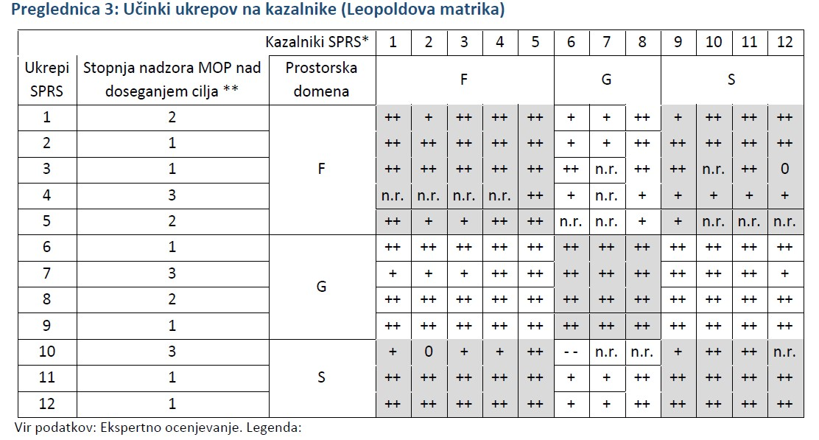

Correlation matrix
 | Env | Econ | Soc
Env | 5 | Te  Strenght of integration = 5 (4 + 5)  Balance = 4 slightly inbalanced to the cost of Economic domain; | Tq  Strenght of integration = 5 (4 + 5)  Balance = 4 slightly inbalanced to the cost of Social domain;
Econ | - | 5 | Ti  Strenght of integration = 4 (3 + 5)  Balance = 4 rather inbalanced to the cost of Economic domain;
Soc | - | - | 5
Scores: 5 (excellent) – 1 (inadequate)

Evaluation Summary
 | Priorities according to the trend analysis 1-3 | Ex-ante impact evaluation of the Strategy, 1-5 | Diffeence between assessed impacts and required direction of structural change
 | a | b | c=b-a
I. Territorial integration domains
F | Third priority (3) | Very positive impacts (1) | Difference: 2 points, Structural score = bad (1)
G | Second priority (2) | Very positive impacts (1) | Difference: 1 point, Structural score = good (3)
S | First priority (1) | Very positive impacts (1) | Difference: 0 point, Structural score = very good (5)
Structural score of impacts on balance (considering priorities) |  |  | GOOD (3)
II. Territorial cohesion domains
Pu | Third priority (3) | very good impacts (1) | Difference: 2 points, Structural score = bad (1)
Pk | Second priority (2) | very good impacts (1) | Difference: 1 point, Structural score = good (3)
Pi | First priority (1) | Least good impacts (3) | Difference: 2 points, Structural score = bad (1)
Structural score of impacts on balance (considering priorities) |  |  | ADEQUATE (2)
OVERALL CONTRIBUTION TO TERRITORIAL INTEGRATION |  |  | GOOD (3)

Results
Resolution on Strategy2050 passed in july 2023:
Word count:
Balance: 23 times (in the meaning of balanced development between economic, social and environmental) Crossection logic: 3 times
Integration / integral: 24 times
Cohesion: 14 times (mostly as a reference to EU policy documents or general concepts of territorial and social cohesion);
Call for Implementation plan until 2034
(outsourced?)
New chapter on implementation:
Policy measures and instruments defined,
(1) Aktivnosti za uveljavljanje in doseganje prostorske kohezije: – nadgrajujejo se obstoječi prostorski instrumenti in razvija nabor ukrepov, ki dodatno krepijo uveljavljanje teritorialnega pristopa; – razširi se nabor instrumentov z gospodarskimi, razvojnimi, participativnimi in komunikacijskimi instrumenti (na primer izobraževanje, usposabljanje, ozaveščanje, informiranje, promocija) ter upravljavskimi instrumenti za usklajevanje navzkrižnih interesov v prostoru;
- preverijo in uveljavijo se vse možnosti doseganja prostorskih ciljev in izvajanja prednostnih nalog z ukrepi drugih resorjev; – vzpostavi in izvaja se integralno presojanje učinkov javnih politik na prostor, vključno s presojanjem učinkov na okolje in prilagajanjem na podnebne spremembe;
- izvajanje strategije se poveže z evropskimi programi, ki so pomembni za prostorski razvoj;
- razvija se integralno upravljanje na čezmejni ravni v skladu s prostorskimi cilji (na primer evropsko združenje za teritorialno sodelovanje – EZTS).

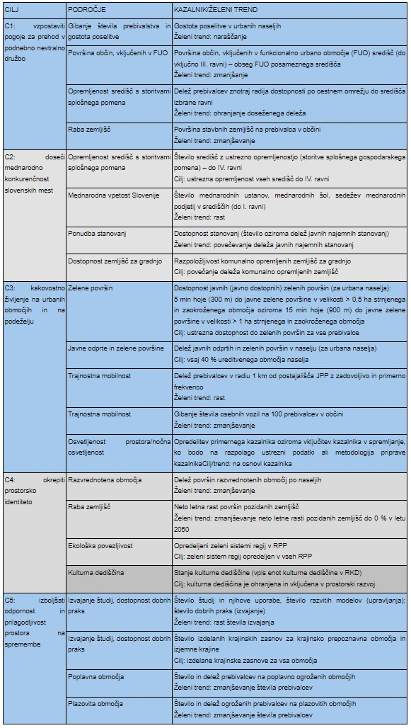
Impacts ?
By 2050:
C1 – suitable conditions for transition into a climate neutral society established
C2 – international competitiveness of slovenian cities achieved
C3 – quality of life in cities and countryside ensured
C4 – territorial identity enhanced
C5 – resilience improved
Indicators for monitoring

